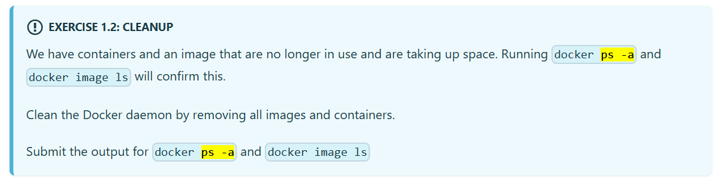

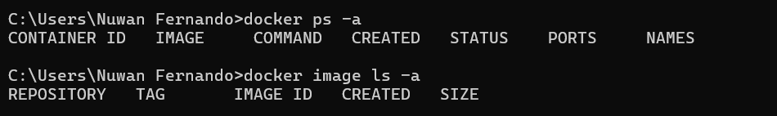

* Start the container

docker run -it --name ubuntu ubuntu sh -c "while true; do echo 'Input website:'; read website; echo 'Searching..'; sleep 1; curl http://$website; done"

* Go inside the container and install curl

docker exec -it ubuntu bash

apt-get update

apt-get -y install curl

**Exercises 1.7 - 1.8**

